SOC Incident Investigation Report
- Document Control Information
- Event ID: 322
- Rule Name: SOC344 - EDR Tampering Attempt via EDR-Freeze
- Severity Level: High / Critical
- Assigned Host: WS-Prod-02 (172.16.20.69)
- Lead Analyst: Sham Kumar - L1 SOC Analyst
- Status: Closed - True Positive / Escalated to Tier-2 IR

1. Executive Summary

- Alert Trigger: The SIEM triggered rule SOC344 after detecting suspicious process behavior and host manipulation on endpoint WS-Prod-02.
- Verdict: TRUE POSITIVE.
- Summary of Event: An external threat actor conducted an RDP brute-force attack against WS-Prod-02, successfully compromising the LetsDefend account. Post-compromise, the attacker initiated system discovery via PowerShell and downloaded a malicious binary (EDR-Freeze_1.0.exe). The utility abused the trusted Windows binary WerFaultSecure.exe to suspend the core Microsoft Defender process (MsMpEng.exe), disabling real-time endpoint security controls. The machine was immediately isolated from the network to halt lateral movement.

2. Key Artifacts & Indicators of Compromise (IoCs)
Category | Artifact / Metric | Context / Value
Alert Info | Alert ID & Title | Event ID 322: SOC344 - EDR Tampering Attempt
Endpoint | Affected Hostname & IP | WS-Prod-02 / 172.16.20.69
Threat Actor | Source External IP | 212.8.243.56 (RDP Connection Origin)
Identity | Compromised Account | ECZAMAZ-ILGVOIN\LetsDefend
Payload | Malicious File Name | EDR-Freeze_1.0.exe
Path | File Directory | C:\Users\LetsDefend\Downloads\
Hash | SHA256 Hash | 970c7834e58b6ef22473875167a333dbb33bf7b667d1cb814829f68579cd85f7
Abused Binary | Living-off-the-Land (LotL) | C:\Windows\System32\WerFaultSecure.exe

3. Detailed Investigation Procedure & Evidence Log

Step 1: Ingestion & Alert Verification
Open SIEM Dashboard and locate Event ID 322.
Verify host ownership and critical network placement for 172.16.20.69.

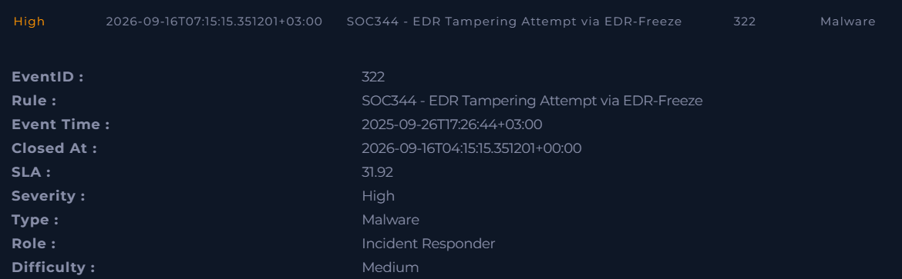

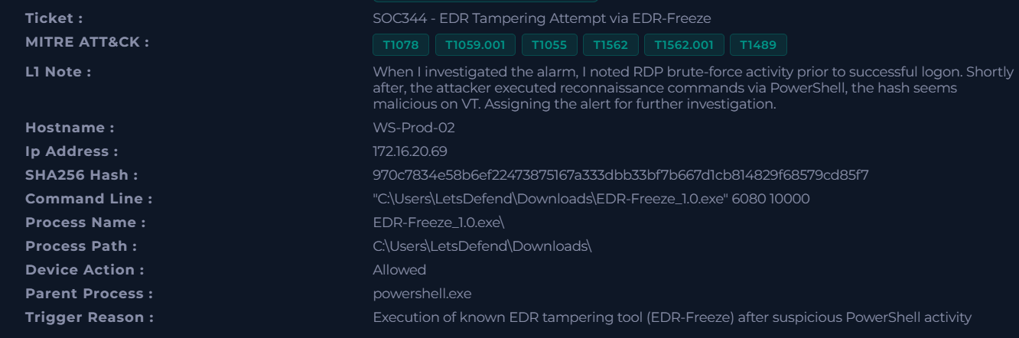

Step 2: Log Management Triage (Authentication Logs)
- Query SIEM/Log Management for Windows Event ID 4625 (Failed Logon) targeting WS-Prod-02.
- Observation: High-volume failed RDP authentication attempts detected originating from external IP 212.8.243.56.
- Query Windows Event ID 4624 (Successful Logon).
- Observation: Successful RDP logon recorded at 13:00:08 UTC for account LetsDefend.

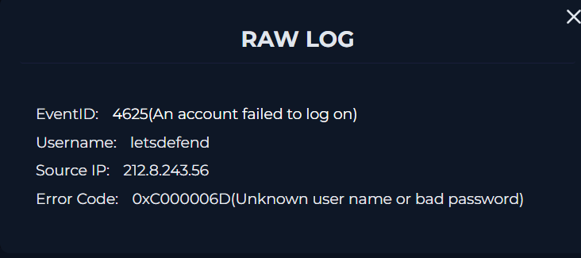

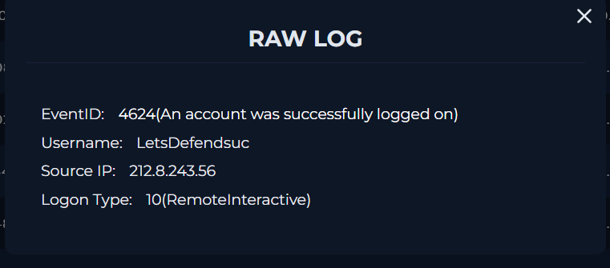

Step 3: Endpoint Detection & Process Execution Analysis (EDR)
- Navigate to Endpoint Security Console for host WS-Prod-02.
- Review process timeline following RDP session establishment:
- powershell.exe executed whoami for initial discovery.
- Browser/PowerShell downloaded file EDR-Freeze_1.0.zip into C:\Users\LetsDefend\Downloads\.
- Command executed:

C:\Users\LetsDefend\Downloads\EDR-Freeze_1.0.exe

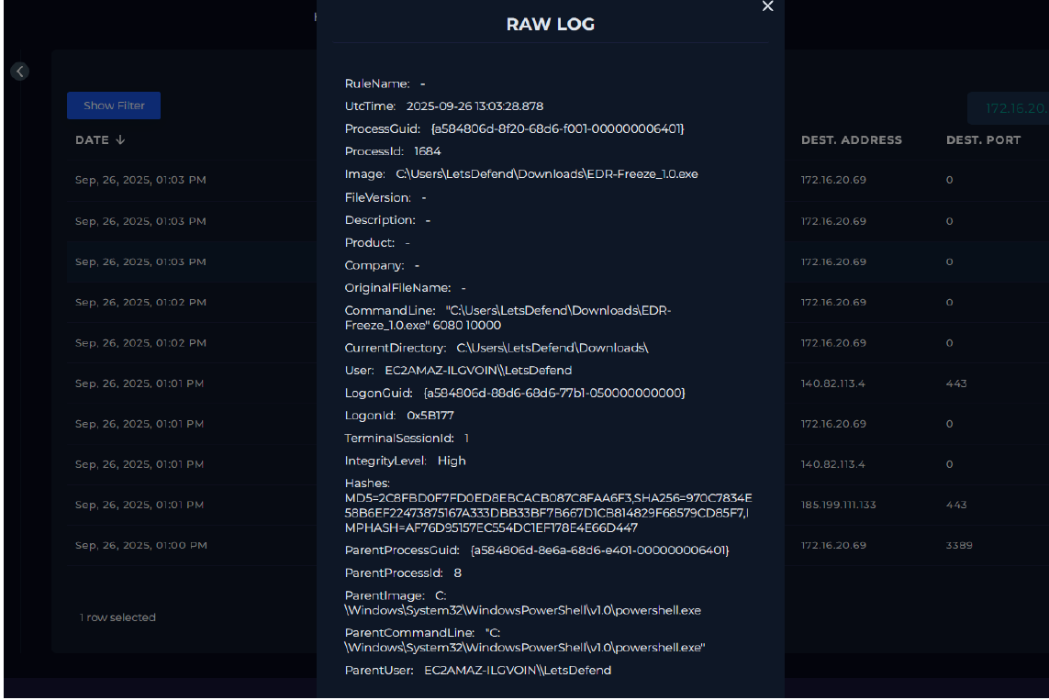

Step 4: Defense Evasion & Sandbox Analysis
- Extract SHA256 hash 970c7834e58b6ef22473875167a333dbb33bf7b667d1cb814829f68579cd85f7 and query VirusTotal / Threat Intelligence feeds.
- Result: 49/72 engines classify as malicious (HackTool/Win64.EDRFreeze).
- Review target execution behavior: EDR-Freeze_1.0.exe spawned system binary WerFaultSecure.exe with execution flags /h /pid 6080 /tid 6076 /encfile.
- Impact: MsMpEng.exe (Microsoft Defender) PID 6080 was put into a suspended state, bypassing detection.

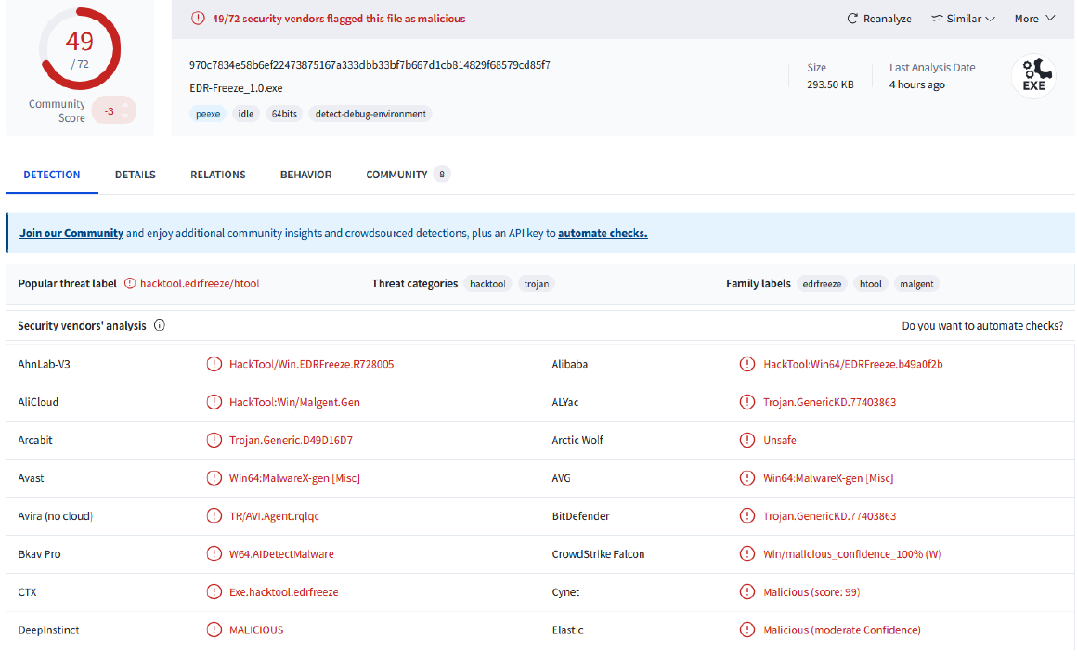

4. MITRE ATT&CK Mapping
Tactic | Technique ID | Technique Name & Applied Evidence
Initial Access | T1078 | Valid Accounts: RDP credential brute-forcing targeting account LetsDefend.
Execution | T1059.001 | PowerShell: Command-line execution for discovery and downloading tools.
Defense Evasion | T1562.001 | Impair Defenses: Tool suspension of Microsoft Defender service (MsMpEng.exe).
Defense Evasion | T1055 | Process Injection / Abuse: Living-off-the-Land exploitation via WerFaultSecure.exe.

5. Containment & L1 Action Steps
- Host Network Isolation: Clicked [Isolate Host] in the Endpoint Security Console for WS-Prod-02 (172.16.20.69) to cut active RDP connections and restrict lateral propagation.
- Perimeter IOC Block: Submitted IP 212.8.243.56 and File Hash 970c7834... to firewall/gateway team for domain-wide blocklist inclusion.
- Escalation: Transferred ticket to Tier-2 Incident Response for credential reset, memory dump extraction, and deep forensic sweep.

6. Preventative Recommendations
- Remote Management Security: Restrict public RDP access behind an enterprise VPN with mandatory Multi-Factor Authentication (MFA) and aggressive lockout thresholds.
- Execution Restrictions: Deploy Software Restriction Policies (SRP) or AppLocker to block executable files running directly from C:\Users\*\Downloads\ directories.
- WerFault Behavioral Alerts: Add SIEM detection rules for non-standard parent-child execution logic involving WerFaultSecure.exe targeting security vendor PIDs.

